0484 932 447
sbg.execofficer@gmail.com
sbg.chair@gmail.com
Southern Biosecurity Group
PO Box 292
Ravensthorpe WA 6346
2019 – 2020
Operational Plan

Introduction

This plan sets out the activities for Southern Biosecurity Group (SBG) for the 2019 – 2020 financial year. Activities identified in this plan are aimed at achieving strategic priorities set out in SBG’s strategic plan (2019-2022). The Biosecurity Management Strategy for the Ravensthorpe Shire was used to inform these activities.

About us
Southern Biosecurity Group is a subgroup of the Ravensthorpe Agricultural Initiative Network (RAIN) with the mandate to coordinate control of declared pest species in the Shire of Ravensthorpe. We first began operating in 2002 as the Ravensthorpe Declared Species Group. At that time, our role involved coordinating wild dog control in the shire. We achieved good control of wild dog numbers through a range of activities including dispersing of 1080 baits, trapping and shooting.
We believe declared pests can be better managed by a coordinated approach between community, industry and government.
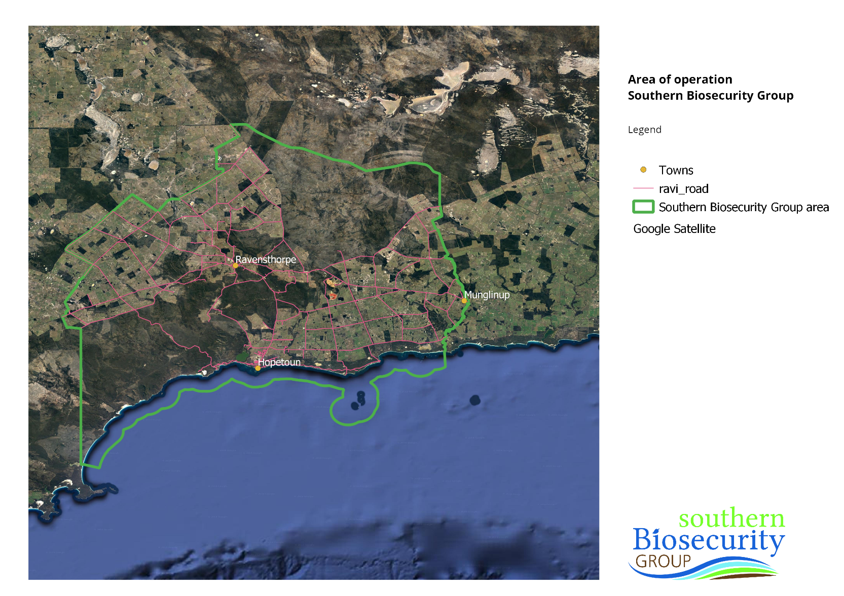
This belief has led us to become a Recognised Biosecurity Group through the Biosecurity and Agricultural Management Act 2007 (BAM Act). This means community funds raised through the Declared Pest Rate are matched dollar for dollar by government, enabling us to provide coordinated and targeted control of declared pests within the shire. The area of operation is shown below.

Aims and objectives
Southern Biosecurity Group will focus on the following key areas that address strategic objectives set out in the 2019 – 2022 Strategic Plan. These are:
- Wild dogs
- Rabbit, fox and cat control
- Governance
- Administration
- Community engagement
A more detailed link of the strategies and actions are provided in Appendix 1.

Declared Pest Rate (DPR) for the SBG area
Funds raised by the DPR and the government co-contribution will support the commercial, environmental and social values of the Ravensthorpe community through:
- Improved animal welfare by preventing wild dog attacks on livestock and native animals
- Add to land values by improving the viability of current and new livestock enterprises
- Strengthen economic return when selling or leasing land suitable for the running of livestock
- Safety of locals and tourists walking, sightseeing and horse riding in bushland areas
- Reduce fox numbers by uptake of baits via wild dog baiting programs
- Impact on fox and rabbit numbers from coordination of annual shoot and release of RHDV1K5 rabbit virus
- Provision of equipment to trap pests impacting on urban areas
- Support endangered species conservation, e.g. numbats and malleefowl
- Prevent the establishment of a wild dog populations within national parks, reserves and urban residential areas
The rate for the 2019/20 financial year will remain unchanged, with the following rates to be applied to all properties.
Hectare range | Flat rate ($)
50ha or less | $24
>50 – 200 | $39
>200 – 500 | $75
>500 – 1000 | $141
>1000 – 2000 | $200
>2000 – 3500 | $377
>3500 – 5000 | $528
>5000 – 7500 | $698
>7500 – 9000 | $848
>9000 | $1107

Committee
Southern Biosecurity Group Committee members are:
Karyn Tuckett
Bevan Tuckett
Gemma Walker
Jennifer Chambers
Reece Laycock

Communications & engagement
A draft calendar of communications and engagement activities has been provided in Appendix 2. It is important to note that this is not a full list as it does not incorporate community activities to increase awareness. Dates for these activities will be set in collaboration with presenters and the community. Other activities will be delivered throughout the year however dates have not yet been established (e.g. community fox shoot). Information will be shared through the SBG website (southernbiosecuritygroup.org.au), the RAIN e-newsletter and the Community Spirit. Other channels, such as social media, will be used as needed.

Community survey
As part of developing the operational plan a priority survey was developed to gain community input. This was made available over November/December 2018. The survey was advertised in the Community Spirit on two occasions. Survey Monkey was also used to create a digital version of the survey. This was promoted through the SBG newsletter and SBG website (homepage).
A total of five responses were received. One response was a direct mail in of the Community Spirit article, the other four were digital responses. Priority species identified were:
- Rabbits
- Wild dogs
- Starlings
- Emu
- Bridal creeper
- Phytophthora dieback
- Apple of Sodom
- Saffron thistle
A key message from this survey was the need to ensure active engagement in community biosecurity.

2019/20 budget
The operational budget for 2019/20 will be $171,620. This includes the landholder rate of $85,810 and the matching funds from the WA State Government. There is no change in the rate from 2018/19. A detailed budget is provided in Appendix 2.

Appendix 1 - Key action areas for SBG for 2019/20
Program | Strategy | Actions
Wild dogs | 1.2 Implement the actions outlined in the Wild Dog Management Plan | 1.2.1: Update the Wild Dog Management Plan and ensure consistency and alignment with the declared pest action plan formats and the National Wild Dog Strategy  1.2.2: Continue to coordinate wild dog management activities (e.g. baiting, shooting and trapping)  1.2.3: Contract services of a licensed pest management technician to carry out control works.  1.2.4: Liaise with other groups who have an interest in wild dog control for joint maintenance, reporting and advocacy  1.2.5: Maintain open communications with DPIRD on the issue  1.2.6: Continue education of the community through e-news and other methods  1.2.7: Work with other groups (e.g. EBA, EWBG) to collectively promote the issue  1.2.8: Promote wild dogs as a state-wide issue
 | 1.3 Provide support for the maintenance of the State Barrier Fence and access roads. | 1.3.1: Report fence conditions to DPIRD and SBF manager and encourage strategic maintenance  1.3.2: Continue minor fence maintenance activities by LPMT
 | 1.4 Encourage UCL track maintenance to access the State Barrier Fence, buffer zone and rock holes. | 1.4.1: Develop a business case articulating the pest and fire control benefits of strategically graded access tracks, outlining the SBG contribution to pest management and recommending strategic works  1.4.2: Present the business case to DBCA, FESA and Shire of Ravensthorpe for incorporation into their Work Plans.
Rabbit, fox and cat control | 1.5 Reduce the numbers and impacts of cats and foxes | 1.5.2: Develop complementary (to Western Shield) cat and fox control measures and private and other lands in the Ravensthorpe Shire  1.5.3: Support research and improved understanding of the ecological interactions between foxes, cats and wild dogs to optimise controls.  1.5.4: Encourage use of cat traps available for community use at RAIN.  1.5.5: Consider purchasing and making available fox traps for community use.
 | 1.6 Reduce the impact of rabbits | 1.6.1: Support the continuation of the RHDV1 K5 rabbit virus release program.  1.6.2: Develop an objective understanding of rabbit population and distribution fluctuations, impacts on agricultural production, and efficacy of control measures in the Ravensthorpe Shire.  1.6.3: Establish project areas for pest animal works and liaise with adjoining public and private landholder to implement an integrated and coordinated program.  1.6.4: Develop information on local effective and preferred control methods.  1.6.5: Support research into the ecological role the rabbit supplies.
Governance | 2.1 Maintain a vibrant and well supported committee | 2.1.1: Identify possible new members for the SBG
 | 2.2 Establish clear planning and reporting processes for the SBG’s strategic direction and operations | 2.2.1: Undertake a Strategic Plan prioritisation process annually  2.2.2: Develop an annual Operational Plan and an associated Budget  2.2.3: Maintain a Risk Management Plan
 | 2.3 Produce clear and simple procedures and templates for the EO role and responsibilities | 2.3.1: Maintain job description forms for key roles (Committee, EO and LPMT)  2.3.2: Maintain a procedures guide to capture key business processes and best practice pest management
Administration | 4.1 Successfully access a diverse range of funding sources | 4.1.1: Develop and maintain a Funding Register of potential funding sources and available grants (Landmark, Elders, Federal Govt, DPIRD, SCNRM, SNRM, AWI, MLA, DBCA, Shires, Indigenous groups, MRWA, Silverlakes, Galaxy, FQM) and update as required.  4.1.2: Access a wide range of funding newsletters for potential opportunities  4.1.3: Develop and maintain SBG Funding Handbook / Filing System of necessary information to assist with efficiently writing funding applications  4.1.4: Develop investment partnerships to implement declared species actions in the Ravensthorpe Shire.
Community engagement | 1.1 Ensure that there is landholder input into declared species priorities | 1.1.1: Seek landholder input into operational declared pest priorities
 | 3.1 Provide tangible value for landholders and community members | 3.1.1: Promote awareness of current relevant pest issues through displays, e-news, newspaper and meetings  3.1.2: Promote group achievements and outcomes from group activities  3.1.3: Encourage community pest surveillance and reporting to the SBG  3.1.4: Hold a community biosecurity event annually  3.1.5: Develop practical tools to assist in the control of declared species (e.g. glove-box guides, apps)  3.1.6: Investigate innovative user-pays services or offers the SBG could provide to community members at a subsidised rate for declared species (e.g. loan traps)  3.1.7: Develop a prospectus on the SBG’s spend on biosecurity and achievements, and communicate to these stakeholders
 | 3.2 Collaborate with the Shire of Ravensthorpe on their Weeds and Pest Policy | 3.2.1: Articulate the Shire’s need to manage pests and weeds on their reserves, camping areas and roadside and the impacts on their budget  3.2.2: Engage with the Shire of Ravensthorpe to develop a Weeds and Pest Policy.  3.2.3: Identify areas for collaboration and seek funding to match SBG in-kind contributions  3.2.4: Develop an MoU to solidify the relationship  3.2.5: Encourage reciprocal weed information sharing and reporting
 | 3.3 Develop strong lines of communication with the DPIRD Biosecurity Team | 3.3.1: Establish direct lines of access to information regarding biosecurity and RBGs  3.3.4: Promote better dissemination of potential funding opportunities to groups and increased collaboration with other RBGs  3.3.6: Establish an MoU including a clear communication protocol
 | 3.4 Better coordinate efforts with DBCA and MRWA management teams | 3.4.1: Continue to collaborate on the timing of baiting and coordination of efforts through open communication of works schedules  3.4.2: Encourage reciprocal weed information sharing and reporting  3.4.3: Develop MoUs for recurrent funding of control activities

Appendix 2 - Communications and engagement calendar

Month | Activities
January | Paddy’s Market – Hopetoun
February | Annual letter to landholders  Community Spirit – article  RAIN e-news – article
March | Quarterly newsletter  Community Spirit – article  RAIN e-news -article
April | Community Spirit – article  RAIN e-news -article
May | Community Spirit – article  RAIN e-news -article
June | Quarterly newsletter  Community Spirit – article  RAIN e-news -article
July | Community Spirit – article  RAIN e-news -article
August | Annual report released  Community Spirit – article  RAIN e-news -article
September | Community priorities survey  Quarterly newsletter  Community Spirit – article  RAIN e-news -article
October | Draft Operational Plan prepared  Community Spirit – article  RAIN e-news -article
November | Community Spirit – article  RAIN e-news -article
December | Quarterly newsletter  Community Spirit – article  RAIN e-news -article

Appendix 3 - Budget for the 2019/20 financial year

INCOME
Declared pest rate | $85,810
DPIRD matching funds | $85,810
TOTAL INCOME | $171,620
EXPENSES
Program 1 – Wild Dogs | $70,992
LPMT Contract | $60,000
Baits and signage | $7,000
Insurance-workers compensation | $3,459
Insurance SBF public liability dogging activity | $889
GIS map development | $250
Program 2 - Complimentary control-rabbit RHDV K5 virus & foxes | $5,397
vials, freight, oats, dispersal, fox baits, equipment, promotion, community fox shoots | $5,397
Program 3 - Governance | $5,824
Executive Officer (part) | $5,000
Teleconference costs | $624
Committee costs | $200
Program 4 – Administration | $60,235
Executive Officer (part) 2 | $25,000
Contingency | $13,000
Subscriptions | $500
Audit | $1,000
RAIN finance admin | $2,772
RAIN 1/3rd share of insurances | $700
Insurance- workers compensation EO | $2,004
RAIN share of office expenses | $5,000
Stationary | $200
Training-event attendance | $3,000
Training allowance travel | $5,000
Equipment replacement account | $2,000
Program 5 – Community Engagement/Operations | $29,172
Executive Officer (part)2 | $16,080
Biosecurity event | $4,383
Market days | $80
Group activities - advertising | $3,500
Annual letter to landholders | $2,512
Maintain electronic presence (website etc.) | $2,000
TOTAL EXPENSES | $171,620

LPMT contract is for 100 days of control works
Executive officer contract for 2019/20 is $46,080, which equates to 3 days per week over 48 weeks.

